SIMATS ENGINEERING (SAVEETHA SCHOOL OF ENGINEERING)
Department of Computer Science and Engineering
CO2 ASSESSMENT TOOL 2 – Architecture Design Assignment
Course Code: | CSA10 / CSA1063 | Course Title: | Software Engineering
CO Assessed: | CO2 | Assessment: | Assessment Tool 2 – Architecture Design Assignment
Weightage: | 20% | Total Marks: | 25
CO2 Statement: | Perform detailed requirements analysis, design scalable architectures, and prioritize features with a focus on cross-disciplinary skills
Student Name: | S. Abisheka Priyen | Reg. No.: | 1911260304
Date: | 26/10/2026 | Duration: | 60 minutes
Code of Conduct
I, S. Abisheka Priyen (1911260304), certify that this submission is my original work and that I have adhered to the guidelines specified for this assessment. I understand that any violation of academic integrity rules will result in disciplinary action.

Signature of the Student:
Annexure A – Architecture Design Assignment
Instructions to Students:
Each student will be assigned an individual software project problem statement. Based on the assigned problem, analyze the system requirements and design an appropriate software architecture by applying software engineering principles.
Question
Based on your assigned problem statement, perform an Architecture Design Analysis and prepare an architecture design report by answering the following questions:
1. Analyze System Requirements: Study objectives, functional and non-functional requirements, and important quality attributes.
2. Select a Suitable Software Architecture: Choose and justify an appropriate architectural style.
3. Draw the Software Architecture Diagram: Show layers, components, databases, external systems, APIs and communication paths.
4. Explain Components and Their Interactions: Explain responsibilities, exchanged data and the overall workflow.
5. Discuss Quality Attributes: Evaluate scalability, security, performance, reliability, maintainability and availability.
6. Justify Architectural Decisions: Explain rationale, trade-offs, future enhancements and integration.

Topic 32 – Real-Time Digital Twin for Industrial Equipment Predictive Maintenance

1. Analyze System Requirements

1.1 Problem and Objectives
Industrial machines such as motors, pumps and compressors can fail unexpectedly, causing production delays and costly maintenance. The proposed digital twin system continuously collects equipment sensor data, creates an up-to-date software representation of machine health, detects abnormal conditions and supports predictive maintenance decisions. It combines real-time telemetry with historical maintenance records, generates alerts and provides a dashboard for operators, technicians and plant managers. Essential local monitoring must continue during temporary network failures.

1.2 Functional Requirements
The system shall register equipment and sensors, ingest timestamped temperature, vibration, pressure and speed readings, validate incoming events, update each digital twin, store historical data, detect anomalies, estimate failure risk, generate severity-based alerts, create and update maintenance work orders and provide secure APIs and dashboards. An edge gateway shall buffer readings and run essential local alert rules when the central service is unreachable, then synchronize events when communication resumes.

1.3 Non-Functional Requirements and Quality Attributes
Scalability is necessary because a plant may add many machines and sensors. Performance requires timely ingestion and dashboard updates; measurable latency targets should be agreed with stakeholders. Reliability and availability require durable messaging, retries, health checks, backup storage and local edge resilience. Security requires authenticated devices and users, role-based access, encryption and audit logging. Maintainability requires modular services, automated tests, documentation, monitoring and CI/CD. Data integrity requires stable equipment identifiers, timestamps and event deduplication.

2. Select a Suitable Software Architecture

2.1 Selected Style: Hybrid Event-Driven Microservices and Edge Architecture
A hybrid architecture combining event-driven microservices with an edge gateway is appropriate for Topic 32. The edge gateway gathers industrial telemetry and runs a limited set of safety-oriented monitoring rules locally. A message broker distributes validated events asynchronously to digital twin, analytics and storage services. Independently deployable services handle alerts, maintenance workflows and API access. This separation makes the platform easier to scale and modify without changing every component.

2.2 Technical Justification
Event-driven processing suits continuous sensor streams because services can consume events at their own pace and the broker reduces tight coupling. Microservices allow ingestion and analytics to scale separately as workloads grow. The edge component reduces dependence on permanent network connectivity. REST APIs give dashboards and maintenance tools a consistent interface. Containerization supports repeatable deployments, while centralized logging, metrics and CI/CD support ongoing operation. Compared with a single monolithic service, the design adds operational complexity, but better fits the requirement for scalable telemetry, analytics and offline monitoring.

3. Software Architecture Diagram
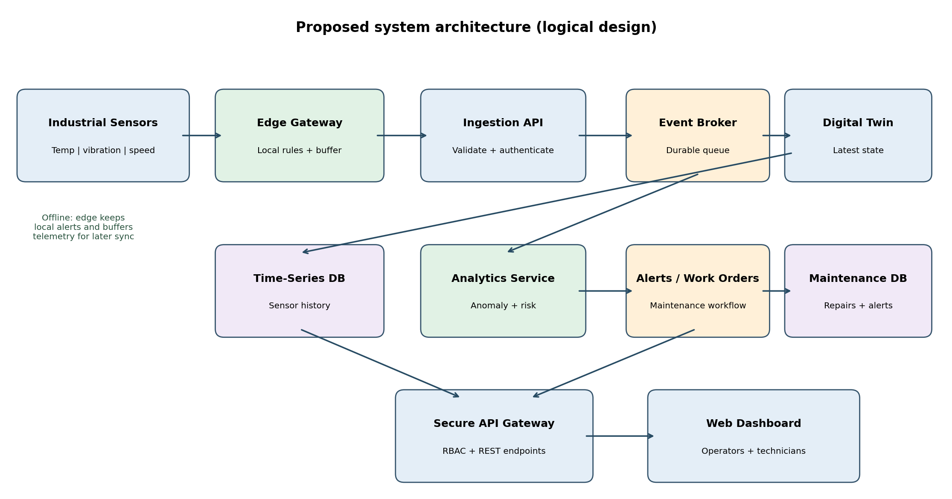
Figure 1. Proposed logical architecture. Arrows indicate major data and service interactions; deployment details may vary.

4. Components and Their Interactions
Component | Responsibility / communication
Industrial sensors | Measure equipment condition and send timestamped readings to the edge gateway.
Edge gateway | Validates basic readings, buffers events and applies local alert rules during disconnection.
Ingestion API and event broker | Authenticate, validate and distribute telemetry asynchronously to consuming services.
Digital twin service | Maintains the latest known operating state and health indicators of each machine.
Time-series database | Stores historical sensor events for trend analysis and predictive modelling.
Analytics service | Uses current and historical data to identify anomalies and estimate maintenance risk.
Alerts and work-order service | Creates notifications and tracks inspection, assignment and repair activities.
Maintenance database | Stores equipment service records, alert states and work-order histories.
API gateway and dashboard | Expose authorized data and present equipment status, trends and maintenance tasks.

4.1 Overall Workflow
A sensor reading reaches the edge gateway, which checks the basic format and forwards it to the ingestion API when connected. The event broker makes the reading available to the digital twin service, historical storage and analytics. The twin service updates the equipment state; analytics examines abnormal patterns and may generate a risk event. The alert service records the event and notifies the appropriate maintenance user. A technician may then create a work order and update the repair history. The dashboard retrieves permitted information through the API gateway.

4.2 Communication Failure Workflow
If the network becomes unavailable, the edge gateway continues essential local rule evaluation and temporarily stores readings with event identifiers. Centralized analytics and dashboards may show stale information during the outage. Once connectivity returns, buffered events are retransmitted, validated and deduplicated to restore the central history. This design supports continuity of monitoring but does not replace dedicated industrial safety systems.

5. Discuss Quality Attributes
Attribute | Architectural support and evaluation
Scalability | Independent consumers and container replicas handle increasing telemetry and API traffic. Load tests should verify the target equipment count.
Security | Device authentication, encrypted transport, RBAC, API validation, audit logs and secret management reduce unauthorized access.
Performance | Asynchronous processing, efficient time-series storage and cached twin state support responsive dashboards. Measure event-to-display latency.
Reliability | Durable queues, retries, idempotent event IDs and health checks help recover from component failures.
Maintainability | Modular services, documented APIs, CI/CD, automated tests and observability simplify updates.
Availability | Redundant central services and local edge monitoring limit interruptions; offline operation remains functionally limited.

5.1 Illustrative Quality Attribute Comparison
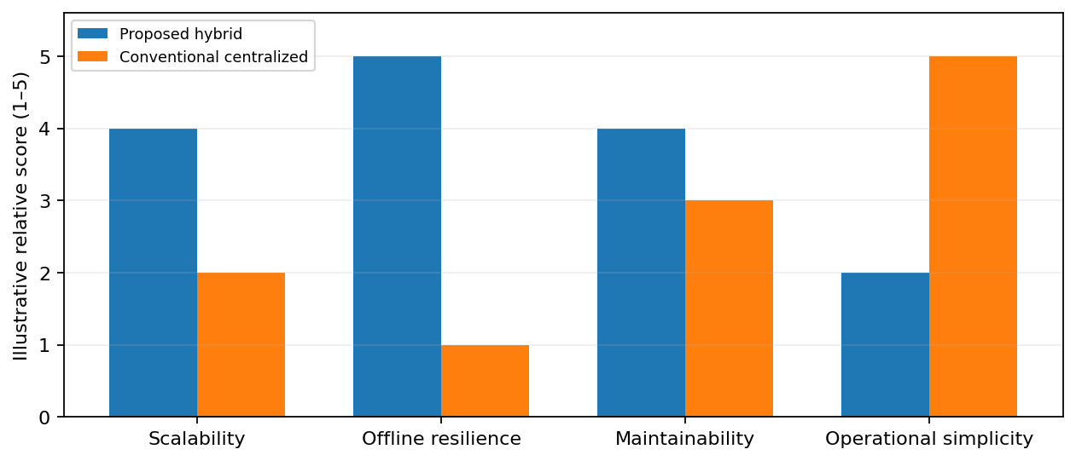
Figure 2. Qualitative design comparison for discussion only; scores are illustrative judgments, not measured industrial performance.

6. Justify Architectural Decisions

6.1 Rationale and Trade-offs
The event-driven hybrid design is selected because the project must correlate continuous telemetry with predictive analytics, maintenance records and live digital twin state. Separating ingestion, analytics and workflow services supports independent scaling and clearer responsibilities. An edge gateway is essential for temporary offline monitoring. The main trade-offs are higher infrastructure complexity, more inter-service communication and the need for disciplined event versioning, distributed tracing and operational monitoring. A monolith could be simpler for a small prototype, but becomes less flexible as sensor traffic and integration needs grow.

6.2 Future Enhancements and Long-Term Maintenance
The architecture can later support additional industrial protocols, multiple factory sites, richer prediction models, remaining-useful-life estimates, mobile technician applications and integration with enterprise maintenance systems. Versioned APIs and event schemas reduce disruption when new features are added. Automated deployment pipelines, model monitoring, data-retention policies, backups and security reviews support long-term maintainability. Predictive alerts should remain explainable and subject to appropriate engineering review.

Rubrics for Calculation
Faculty assessment rubric – CO2 Assessment Tool 2 (25 marks).
Evaluation Criteria | Excellent (4 Marks) | Good (3 Marks) | Satisfactory (2 Marks) | Needs Improvement (1 Mark)
System Requirement Analysis (30%) | Thoroughly analyzes the problem statement, accurately identifies functional and non-functional requirements, and clearly explains quality attributes influencing the architecture. | Analyzes most requirements with minor omissions or limited explanation. | Identifies only basic requirements with partial analysis. | Requirement analysis is incomplete, inaccurate, or lacks clarity.
Selection of Software Architecture (25%) | Selects the most appropriate architectural style with strong technical justification aligned to system requirements. | Selects a suitable architecture with reasonable justification. | Architecture is partially suitable with limited justification. | Inappropriate architecture selected or justification is missing.
Architecture Diagram and Component Design (20%) | Produces a clear, complete, and well-structured architecture diagram with all major components, interfaces, and interactions accurately represented. | Diagram is mostly complete with minor omissions or notation issues. | Diagram includes only essential components and lacks sufficient detail. | Diagram is incomplete, unclear, or technically incorrect.
Component Interaction and Quality Attribute Analysis (15%) | Clearly explains component responsibilities, interactions, and thoroughly discusses scalability, security, performance, reliability, maintainability, and availability. | Explains most components and quality attributes with minor gaps. | Provides limited explanation of interactions and addresses only some quality attributes. | Component interactions and quality attributes are poorly explained or missing.
Architectural Justification and Technical Presentation (10%) | Provides strong justification for architectural decisions, discusses trade-offs and future enhancements, and presents a well-organized, professional report. | Provides adequate justification with minor gaps; report is well organized. | Limited justification with minimal discussion of trade-offs or future scope; report needs improvement. | Justification is weak or absent; report lacks organization and technical clarity.

Criteria | Mark
System Requirement Analysis (30%) | /5
Selection of Software Architecture (25%) | /5
Architecture Diagram and Component Design (20%) | /5
Component Interaction and Quality Attribute Analysis (15%) | /5
Architectural Justification and Technical Presentation (10%) | /5
TOTAL | /25

